FRONT END – PART 1
FLEX

(Make Flex Work)
1. Which property is necessary to add to element to make the flex properties work?
a) display: flex-container; b) display: flexbox;
c) display: flex; d) there is no such property

(Direct the Items)
2. Which property defines in which direction the container wants to stack flex items?
a) flex-flow b) flex-wrap
c) flex-direction d) flex-content

(Column Reverse)
3. The default behaviour for 'flex-direction' is "row" as shown in figure below -

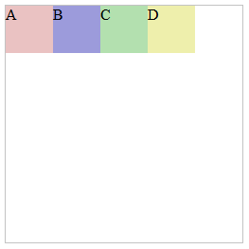

Which of the following image represents the behaviour when 'flex-direction' is set to "column-reverse".

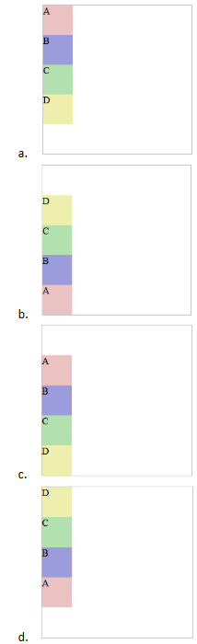
a) b b) a
c) d d) c

(Order of Elements)
4. What will be the order of the elements when the “flex-direction: row-reverse” is set with the following properties-

#div1 {order: 20;}
#div2 {order: 14;}
#div3 {order: 31;}
#div4 {order: 6;}
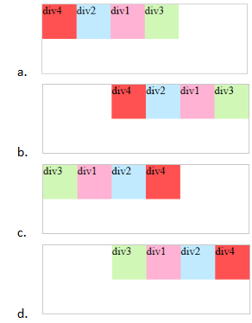

a) b b) a
c) d d) c

(Default Orientation)
5. What is the default orientation within a flex container?
a) horizontal b) vertical
c) diagonal d) perpendicular

(Order Property)
6. The "order" property for flex items allows you to -
a) Specify at what time flex items appear. b) Specify in what direction the flex items appear.
c) Specify in what order the flex items appear. d) None of the above.

(Flex Wrap)
7. The flex-wrap property is a quick way to make parent elements more responsive on various screen sizes.
a) True b) False

(Flex-Container Flexible)
8. Which of the following is the correct form to make a flex-container flexible?
a) .flex-container { display: flex; flex-wrap: wrap; } b) flex-wrap: no-wrap;
c) None of the above
SOLUTION DESCRIPTION:
Explanation: The flex-wrap property specifies whether the flexible items should wrap or not. If the elements are not flexible items, the flex-wrap property has no effect. So you have to make an element a flex container by adding display: flex before specifying flexbox wrap property.

(Flex Wrap)
9. What is the default value for the "flex-wrap" property?
a) wrap b) nowrap
c) wrap-reverse d) none

(Correct Output 1)
10. What will be the output of the below given code?

<!DOCTYPE html>
<html>
<head>
<style>
.flex-container {
display: flex;
flex-wrap: nowrap;
background-color: #8ffcc9;
width: 400px;
}
.flex-container>div {
background-color: white;
width: 40px;
margin: 5px;
text-align: center;
line-height: 50px;
font-size: 30px;
}
</style>
</head>
<body>
<div class="flex-container">
<div>1</div>
<div>2</div>
<div style="flex-grow: 3">3</div>
<div>4</div>
<div>5</div>
<div style="flex-shrink: 2">6</div>
<div>7</div>
</div>
</body>
</html>

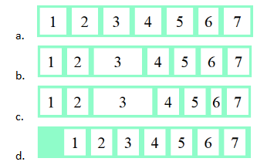

a) b b) a
c) d d) c

(Correct Output 2)
11. What will be the output of the below given code?

<!DOCTYPE html>
<html>
<head>
<style>
.flex-container {
display: flex;
flex-wrap: wrap-reverse;
background-color: #8ffcc9;
width: 400px;
}
.flex-container>div {
background-color: white;
width: 60px;
margin: 5px;
text-align: center;
line-height: 50px;
font-size: 30px;
}
</style>
</head>
<body>
<div class="flex-container">
<div style="flex-grow: 5;">1</div>
<div style="flex-shrink: 1;">2</div>
<div style="flex-shrink: 2;">3</div>
<div style="flex-shrink: 1;">4</div>
<div style="flex-grow: 5;">5</div>
<div style="flex-grow: 1;">6</div>
<div style="flex-grow: 2;">7</div>
</div>
</body>
</html>

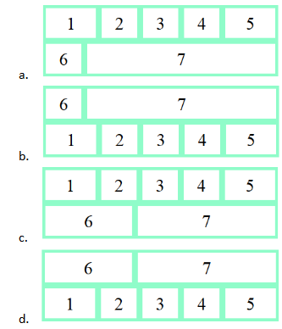

a) b b) a
c) d d) c

(Center Align)
12. Aligning the flex items at the 'center' using the "align-items" property would be best displayed from which of the following image?

The value of "flex-direction" property is set to "row".
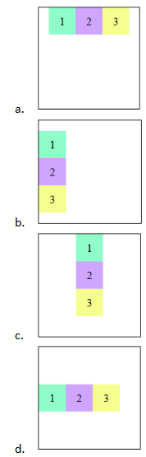

a) b b) a
c) d d) c

(Align Flex Items)
13. Which property is use to align flex items along main axis?
a) align-items b) justify-content
c) align-content d) flex-grow

(Center Center)
14. If the property "justify-content: center;" and "align-items: center;" are used together inside a flex-container, then how it look now in the browser?

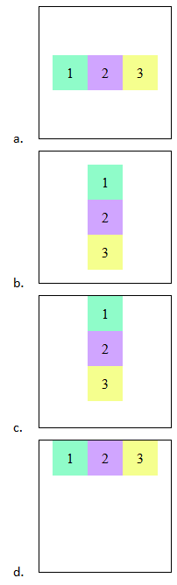
a) b b) a
c) d d) c

(Align-items)
15. The flexbox property “align-items” allows you to -
a) Define how elements will wrap when the browser width is changed.
b) Define the direction of how elements are positioned based on either row or column.
c) Define how to position elements on the main axis (horizontally).
d) Define how to position elements on the cross axis (vertically).

(Pseudo Class)
16. Which statements are correct about pseudo-class in CSS?
a) Pseudo-classes are keywords added to a selector and separated using a single colon(:).
b) pseudo-class is used to define a special state of an element.
c) Syntax for pseudo-class is: selector:pseudo-class { property: value; }
d) None of the above.

(nth-child)
17. Let’s say you want to set every odd-numbered paragraph element to be a green color using pseudo-class, what will be the correct syntax for that?
a) p : nth-child(2n+1) { color: green; } b) p : nth-child(odd) { color : green; }
c) p : nth-child(odd-child) { color : green; } d) None of the above.

(Layout Dimension)
18. Which layout model defines the structures similar to tables using 2 dimensions?
a) Flexbox b) Grid
c) Flexbox and Grid d) None of the above

(Grid Container)
19. To make an HTML element behave as a grid container, you have to set the display property to -
a) grid b) inline grid
c) grid container d) None of the above.

(Require Container)
20. What layout modules require containers?
a) Flexbox b) Grid
c) Position d) Float

ASSIGNMENT

(Align Flex Lines)
21. Which property is used to align flex lines?
a) align-items b) justify-content
c) flex-align d) align-content

(Shorthand Property)
22. In the shortened property flex: 1 0 auto; which property refers to the 2nd value (here 0)?
a) flex-grow b) flex-basis
c) flex-shrink d) flex-flow

(Override)
23. Which of the following overrides container’s align-items property?
a) order b) align-self
c) align-items d) flex

(Guess the Width)
24. If the below two properties are applied on a flex item -

width: 500px;
flex-basis: 250px;

What will be its width?
a) 250px b) 500px
c) 750px d) auto
SOLUTION DESCRIPTION:
The "width" property gets overridden by "flex-basis" property. So, "flex-basis: 250px;" gets applied and the width of the element becomes "250px".

(Find the Width)
25. If the below three properties are applied on a flex item -

width: 500px;
flex-basis: 250px;
min-width: 750px;

What will be its width?
a) 250px b) 500px
c) 750px d) 1250px
e) auto
SOLUTION DESCRIPTION:
The "min-width" property fixes a boundary for the width of the element and cannot be overridden in any way. So, even though "flex-basis" sets the initial width, the "min-width" is not fulfilled, so width of the element becomes "750px".

(Find the gap)
26. A small necessary code is provided for the given flex container as shown in image below -

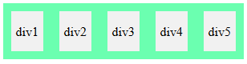

Code:-

.flex-container {
display: flex;
justify-content: space-between;
width: 300px;
flex-wrap: nowrap;
}
.flex-container > div {
background-color: #f1f1f1;
width: 50px;
margin: 10px;
}

What is the space between any of the 2 divs?
a) 20px b) 30px
c) 10px d) 15px

(View in Browser)
27. How will the below code look in the browser?

<!DOCTYPE html>
<html>
<head>
<style>
.flex-container {
display: flex;
background-color: #6bffb0;
width: 200px;
height: 200px;
flex-wrap: wrap;
justify-content: space-between;
align-content: center;
}
.flex-container > div {
background-color: #f1f1f1;
width: 50px;
margin: 10px;
text-align: center;
line-height: 40px;
font-size: 16px;
}
</style>
</head>
<body>
<div class="flex-container">
<div style="order: 2;">div1</div>
<div style="align-self: flex-start;">div2</div>
<div style="">div3</div>
<div style="order: 5; flex-grow: 1;">div4</div>
<div style="flex-grow: 2">div5</div>
</div>
</body>
</html>

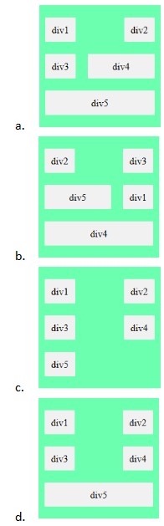

a) b b) a
c) d d) c

(Look in Browser)
28. Study the code below and tell how would it look in the browser?

<!DOCTYPE html>
<html>
<head>
<style>
.flex-container {
display: flex;
background-color: #6bffb0;
width: 350px;
height: 100px;
flex-flow: row-reverse nowrap;
justify-content: space-between;
align-content: flex-end;
}
.flex-container > div {
background-color: #f1f1f1;
margin: 10px;
text-align: center;
line-height: 40px;
font-size: 16px;
}
</style>
</head>
<body>
<div class="flex-container">
<div style="flex: 0 1 70px; align-self: baseline; order: 10;"><h4>div1</h4></div>
<div style="flex: 1 0 70px; align-self: baseline; order: 3;">div2</div>
<div style="flex: 0 0 70px; order: 5;"><h2>div3</h2></div>
<div style="flex: 1 5 70px; order: 2;">div4</div>
<div style="flex: 5 1 70px; align-self: flex-end; order: 8;">div5 </div>
</div>
</body>
</html>

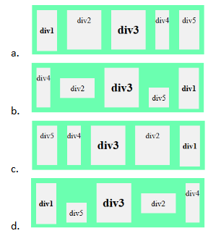

a) b b) a
c) d d) c

(Flex-flow)
29. flex-flow is a shorthand property that combines-
a) flex-direction and flex-wrap b) flex-direction and flex-basis
c) flex-direction and flex-grow d) flex-direction and flex-shrink

(Grid Template Column)
30. grid-template-columns property can be used to :
a) Specify the size of the column. b) Specify the size of the row.
c) Specify the automatic size of the columns d) None of the above.
SOLUTION DESCRIPTION:
Explanation: The grid-template-columns property specifies the number of the columns in a grid layout. The values are a space-separated list, where each value specifies the size of the respective column.

(Fraction Unit)
31. Suppose you are creating a grid layout like this-

.container{
width : 400px;
display: grid;
grid-template-columns: 125px 125px 1fr 1fr;
}

What does 1fr mean in the above code?
a) The first two columns will be two fraction units of the stated width.
b) The third and fourth columns are 1 fraction units of the remaining space in the grid.
c) The second column will be half of the remaining space in the grid.
d) The second column will be double the stated width.
SOLUTION DESCRIPTION:
Explanation: Since fr is a fractional unit and 1fr is for 1 part of the available space.
Here, you have a grid with 4 columns as in the mentioned code, the 1st and second columns will be 125px, the 3rd and 4th columns will be 75px (each occupying half of the remaining space).

**********

